BLOOMERS ISLAND PILOT

By: Cynthia Wylie

Cynthia Wylie
PO Box 469
Venice CA 90294
323 855 6756
cynthiawylie@gmail.com WGAw # 2019517
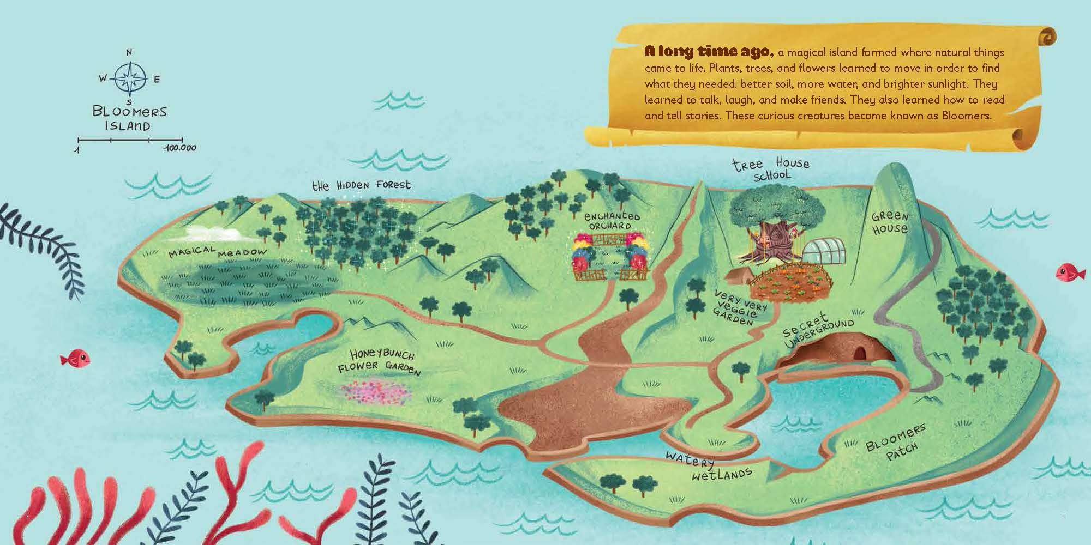

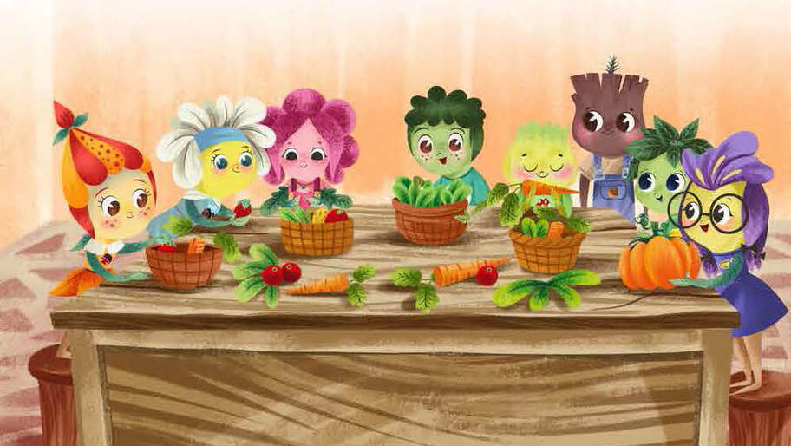

The Great Garden Party. From the Bloomers Island book series.
©2018 Penguin Random House

BLOOMERS ISLAND

EXT. OCEAN - DAY

Aerial view as we glide across an endless ocean only a hundred feet above the white-tipped, teal waves. A ukulele plays a life-affirming island tune.

A wonky, green bird with a bright orange beak unexpectedly flaps into our view and then back out. What was that?

EXT. ISLAND - DAY

We see a beach up ahead. We speed over palm trees, wetlands and lush foliage until we come to…

EXT. TREE HOUSE SCHOOL – DAY

…the foot of an ancient Banyan Tree, holding a primitive schoolhouse and juggling a straw outbuilding in one branch and a giant toadstool in the other. Roots and vines topple over his branches and puddle on the ground. Crooked ladders of driftwood reach from the ground into the buildings. He has a timeworn face peeking above the schoolhouse with a lopsided grin. His name is MR. BANYAN.

A little green man stands under Mr. Banyan. He is wearing robes of various colors of indigo. His feet are brown roots resting on the dirt path, his toes digging into the ground. His arms are stems and it looks like he is wearing green mittens, but it is his hands that are a leaf with another smaller leaf as an opposable thumb.

On his head is a bouquet of floppy green, rounded leaves. And his smile has a droopy leaf moustache on either side with an enormous pair of deep blue, framed spectacles covering the top half of his face. Somewhere behind those spectacles there are two playful, inquisitive eyes. His name is PROFESSOR SAGE.

At the roots of Professor Sage sits a brown and white spotted puppy with cream colored petals around his neck. It is his puppy, DOG WOOD.

PROFESSOR SAGE
Mr. Banyan!

MR. BANYAN
(Talks very slowly like everything else he does)
Professor Sage. It is going to be a beautiful
Day.

PROFESSOR SAGE
(With a knowing wink)
Thank you for the daily weather update.
Are you prepared for our new crop
of students?

MR. BANYAN
The schoolhouse feels a bit too light.

PROFESSOR SAGE
Indeed, indeed!

Professor Sage peers through his spectacles down the hill and rubs his leaf hands together.

CUT TO:

Eight students that look to be various trees, plants and flowers stand looking up into the Tree House School with awe.

Professor Sage gathers his robes and walks down to the front.

PROFFESOR SAGE
Welcome to the Tree House School, Bloomers.
Here, you will learn to cultivate yourself.
You will learn that you are capable of so much more than you think. You must know that you will inspire others when you don’t even know you’re
doing it. You are brave and will learn to
weather the storms. And while that is happening,
we will all enjoy lots of adventures…

At that exact moment, a gigantic swarm of BEETLES comes around Bloomers Mountain and almost like a black cloud, they begin descending on the Bloomers, buzzing and chomping. The Bloomers start yelling and swatting at the beetles.

PETE MOSS, a dark green-ish, turquoisey plant with a mop of petals on his head, a t-shirt that reads, DIGGITY, and a cape made of a leaf tumbles down the path somersault after somersault.

BIG RED, a large Red Wood Tree with red cheeks and one twig of needles on the top of his head takes off, his footsteps shaking the ground.

LILLY, an orange flower girl with her orange spotted petals tied up in a blade of grass, and a freckled pale orange face, and ROSEY POSEY the Island’s most beautiful flower with pink petals surrounding a pale pink face, grab hands and follow Pete Moss down the path from the Tree House School. Lilly’s petals come undone and flutter into her face.

DAISY, a flower girl with a yellow face and white petals held up with a light blue headband, sprints ahead with VIOLET, a deep purple flower girl with a yellow face and large plastic glasses. Violet’s glasses fall off her face and as she stops to retrieve them, Daisy pulls her along.

A proper young plant, BASIL, yips and jumps from foot to foot, looking down and vigorously shaking the Beetles off the leaves on his head.

BUD INSKI, a yellow-green plant with cone-shaped petals growing bud-like on the top of his head, ducks under Professor Sage’s robes.

Dog Wood barks and barks. It is bedlam.

Professor Sage yells after them,

PROFESSOR SAGE
Wait, wait Bloomers. Don’t run down
there!

Pete Moss tumbles right off the edge of the cliff yelling on the way down and the last we hear is a huge splash from below.

Rosey and Lilly stop just in time at the very edge, but Daisy and Violet run into them from behind. They almost fall off the cliff. Against all odds, they manage to hold on to each other.

Big Red runs in circles, shaking the ground with every step. He stops unexpectedly just before squashing a Lady Bug. But he picks her up and sets her down off the path.

BIG RED
Your Lady, Big Red at your service.

Before she can thank him, he continues on his circular path (as if that’s going to help him). Beetles are landing on his head and he swats at them furiously squishing his lone twig of needles.

Suddenly, a flock of BIRDS OF PARADISE, majestically flapping their dark green leaves, fly around Mr. Banyan, scooping up beetles in their bright orange flowers.

The Bloomers look around. In short order, most of the Beetles are gone.

Big Red feels the top of his head, straightens his twig, and adjusts his needles. Lilly fastens her petals again. Rosey pulls out a powder puff and powders her nose. Violet is down on her knees patting the ground with her leaves, looking for her glasses which, thank goodness Daisy has found and hands to her. Basil faints and slips to the ground. Bud comes out from behind Professor Sage’s robes. Big Red helps Basil to his feet.

Basil does an inventory of his leaves hanging in front of his face. He sees a big hole in one of them that has a beetle still there, munching. He shrieks and knocks the beetle to the ground. It flies away.

BASIL
(horrified)
Look at my leaf! There’s a hole in it!

Rosey comes up next to him.

ROSEY POSEY
I can fix that. I do petal-cures.
I’m going to open a shop when I
graduate.

Pete Moss’s head appears at the edge of the cliff. He lifts himself up and plops down shaking the water out of his petals. He grins.

PETE MOSS
That was fun!

PROFESSOR SAGE
See?! I told you. You are all braver
than you think.
.
The Bloomers look stunned.

PROFESSOR SAGE (cont’d)
Let’s all introduce ourselves, shall we?
Basil?

Basil raises his hand.

BASIL
It’s pronounced Basil.
(drawing out the “a” in his name like
ahhhh)

PROFESSOR SAGE
You say tomato. I say tomahto.
Rosey Posey?

Rosey steps forward with an eyeroll and an attitude.

PROFESSOR SAGE (cont’d)
Big Red?

Big Red steps toward Professor Sage, his big roots making an impact.

PROFESSOR SAGE (cont’d)
Lilly?

Lilly clicks her roots together.

LILLY
Here, sir!

PROFESSOR SAGE
Violet?

Violet is looking up at the clouds drifting by.

PROFESSOER SAGE (cont’d)
Violet?

Violet snaps to attention.

VIOLET
Oh! Sorry. Here I am.
PROFESSOR SAGE
Pete Moss?

Pete Moss shakes water out of his petals again and grins.

PETE MOSS
That was super fun! Can I jump off the
Cliff again?!

PROFESSOR SAGE
Maybe later young sprout. And
last but not least, Bud Inski?

Bud shyly scrapes the dirt with his root. Looks up.

BUD INSKI
Professor Sage, you know who I am.
You raised me!

PROFESSOR SAGE
Well yes, Bud, but your new friends
don’t know you yet.

Bud raises his hand.

BUD INSKI
Hi. I’m Bud, Everyone.

Professor Sage claps his hands.

PROFESSOR SAGE (cont’d)
Now let’s get you settled in. The
Golden Sun is setting. Girls in
the Mushroom Dormitory. Boys in the Straw
Hut Dorm.

The Bloomers climb the ladders into their dorms. Mr. Banyan picks up their bags with a spare branch and places them in front of the doors. As soon as they are out of sight …

… the Birds of Paradise land in front of Professor Sage. They are all dressed like World War I aces with leather hats, the ear flaps hanging down and unbuckled. Some are wearing goggles. Wearing white silk scarves around their neck stems, they start coughing and the Beetles come tumbling out. The Beetles start elbowing each other and grumbling.

BEETLES
Hey watch it. Hey move over. Out of my way.

One of the Birds starts bragging.

BIRD #1
Did you see that bank turn I did?

The other birds nod their heads, appreciatively.

PROFESSOR SAGE
Good job Beetles and Birds! Thanks to all
of you, the Bloomers know they are braver
than they thought. That completes our orientation.

They all fly off, while waving good bye to Mr. Banyan.

BIRDS AND BEETLES
Any time, Professor Sage.

INT. MUSHROOM DORM – DUSK

The interior of the Flower Girl’s dorm is wallpapered with horizontal stripes of pink and orange. There are four flower beds, filled with rich soil, in a neat line. The floor is tiled with pale white stones. The Girls put away their clothes – a few outfits each - in a closet. Rosey just sets up her trunks and opens them. Hanging on bars inside the trunks are outfit after outfit after outfit – all of them in shades of pink. She plops down on a flower bed with a loud groan.

ROSEY
I’m not so sure I like it here.

LILLY
But Professor Sage told us there are
going to be a lot of adventures. Sign
me up.

VIOLET
I think the Boy Bloomers are dreamy.

Daisy beeps her horn several times. Everyone stares at her, questioningly.

VIOLET (cont’d)
I can translate horn language. Um,
Daisy thinks we should at least give
it a chance.

Daisy nods her head up and down.

INT. STRAW HUT DORM – DUSK

Inside the straw hut are four hammocks swinging from the rafters. The walls are pale straw, the floor is covered in soft brown soil. The Boys are also trying to put away their clothes. Pete Moss is bouncing off of all the hammocks. Basil neatly puts all his clothes in one side of the closet.

Big Red picks up his duffle bag, heading toward the closet, trips over his big roots, and lands with a thud as the bag opens, dumping its contents onto the floor. He gets up, embarrassed, looks at the clothes strewn about.

BASIL
Would you like me to help you with
that, Big Red?

BIG RED
(comforted)
Yes, thank you.

As Basil picks up Big Red’s clothes, Pete Moss does a somersault and lands on the floor. He opens his back pack and stuffs the few outfits into a dresser drawer, then resumes jumping around the room.

Bud, holding a small suitcase, is watching the scene unfold from the doorway. Big Red motions to him.

BIG RED
Come in little Buddy.

Bud grins from leaf to leaf and you can see his relief at being included. He kicks the dirt with his root toe. He walks over to the closet and empties his clothes into a drawer. He tries to reach the lowest shelf to place his suitcase there, but even on tippy roots, he cannot. Big Red walks over, grabs his suitcase and places it on the shelf.

BUD INSKI
Thanks, Big Red.

BIG RED
(proudly)
No problem. It comes in handy
from time to time. Being tall that is.

The Boys jump onto their hammocks. Big Red’s strains and the rafters creak, but it holds.

The last rays of the Golden Sun fade in the room.

INT. STRAW HUT DORM – NIGHT

The room is now as black as a chalkboard. Out of the darkness we hear …

BASIL
Another Beetle!!!!!!

It buzzes away.

INT. – GIRL’S DORM – NIGHT

LILLY
Good night Rosey. Good night Violet.
Good night Daisy.

ROSEY POSEY
Good night Lilly. Good night Violet.
Good night Daisy.

VIOLET
Good night Lilly. Good night Rosey.
Good night Daisy.

Daisy beep her horn three times.

INT. – PROFESSOR SAGE’S ROOM – NIGHT

Professor Sage blows out a candle on his desk.

EXT. TREE HOUSE SCHOOL – NIGHT

A crescent moon peeks through the clouds. Mr. Banyan hugs his tree house just a little bit tighter.

